Sample Tweet JSON Data

{

"created_at":"Thu May 05 21:52:41 +0000 2016",

"id":728341672292143104,

"id_str":"728341672292143104",

"text":"New Milwaukee Tool M18 LED Work Light Model # 2735-20 - Bid Now! Only $33.0 https:\/\/t.co\/UcNkPUfsH3 https:\/\/t.co\/OXoNAF5mUR",

"source":"\u003ca href=\"http:\/\/ifttt.com\" rel=\"nofollow\"\u003eIFTTT\u003c\/a\u003e",

"truncated":false,

"in_reply_to_status_id":null,

"in_reply_to_status_id_str":null,

"in_reply_to_user_id":null,

"in_reply_to_user_id_str":null,

"in_reply_to_screen_name":null,

"user":{

"id":4200580395,

"id_str":"4200580395",

"name":"Xeabfu Ruibju",

"screen_name":"Xeabfu__Ruibju",

"location":"New York, USA",

"url":null,

"description":"Music,sports,photografy,travel,shopping,internet",

"protected":false,

"verified":false,

"followers_count":85,

"friends_count":0,

"listed_count":526,

"favourites_count":0,

"statuses_count":248299,

"created_at":"Mon Nov 16 08:58:05 +0000 2015",

"utc_offset":null,

"time_zone":null,

"geo_enabled":false,

"lang":"pl",

"contributors_enabled":false,

"is_translator":false,

"profile_background_color":"C0DEED",

"profile_background_image_url":"http:\/\/abs.twimg.com\/images\/themes\/theme1\/bg.png",

"profile_background_image_url_https":"https:\/\/abs.twimg.com\/images\/themes\/theme1\/bg.png",

"profile_background_tile":false,"profile_link_color":"0084B4",

"profile_sidebar_border_color":"C0DEED",

"profile_sidebar_fill_color":"DDEEF6",

"profile_text_color":"333333",

"profile_use_background_image":true,

"profile_image_url":"http:\/\/pbs.twimg.com\/profile_images\/666178889903833088\/KV_UfeVK_normal.jpg",

"profile_image_url_https":"https:\/\/pbs.twimg.com\/profile_images\/666178889903833088\/KV_UfeVK_normal.jpg",

"profile_banner_url":"https:\/\/pbs.twimg.com\/profile_banners\/4200580395\/1447664432",

"default_profile":true,

"default_profile_image":false,

"following":null,

"follow_request_sent":null,

"notifications":null

},

"geo":null,

"coordinates":null,

"place":null,

"contributors":null,

"is_quote_status":false,

"retweet_count":0,

"favorite_count":0,

"entities":{

"hashtags":[],

"urls":[{

"url":"https:\/\/t.co\/UcNkPUfsH3",

"expanded_url":"http:\/\/rover.ebay.com\/rover\/1\/711-53200-19255-0\/1?ff3=2&toolid=10044&campid=5337410320&customid=&lgeo=1&vectorid=229466&item=172187625963&pub=5575041009",

"display_url":"rover.ebay.com\/rover\/1\/711-53\u2026",

"indices":[76,99]

}],

"user_mentions":[],

"symbols":[],

"media":[

{

"id":728341671977553920,

"id_str":"728341671977553920",

"indices":[100,123],

"media_url":"http:\/\/pbs.twimg.com\/media\/ChuW5ElWEAAE-wL.jpg",

"media_url_https":"https:\/\/pbs.twimg.com\/media\/ChuW5ElWEAAE-wL.jpg",

"url":"https:\/\/t.co\/OXoNAF5mUR",

"display_url":"pic.twitter.com\/OXoNAF5mUR",

"expanded_url":"http:\/\/twitter.com\/Xeabfu__Ruibju\/status\/728341672292143104\/photo\/1",

"type":"photo",

"sizes":{

"medium":{

"w":140,

"h":140,

"resize":"fit"

},

"small":{

"w":140,

"h":140,

"resize":"fit"

},

"thumb":{

"w":140,

"h":140,

"resize":"crop"

},

"large":{

"w":140,

"h":140,

"resize":"fit"

}

}

}

]},

"extended_entities":{

"media":[{

"id":728341671977553920,

"id_str":"728341671977553920",

"indices":[100,123],

"media_url":"http:\/\/pbs.twimg.com\/media\/ChuW5ElWEAAE-wL.jpg",

"media_url_https":"https:\/\/pbs.twimg.com\/media\/ChuW5ElWEAAE-wL.jpg",

"url":"https:\/\/t.co\/OXoNAF5mUR",

"display_url":"pic.twitter.com\/OXoNAF5mUR",

"expanded_url":"http:\/\/twitter.com\/Xeabfu__Ruibju\/status\/728341672292143104\/photo\/1",

"type":"photo",

"sizes":{

"medium":{

"w":140,

"h":140,

"resize":"fit"

},

"small":{

"w":140,

"h":140,

"resize":"fit"},

"thumb":{

"w":140,

"h":140,

"resize":"crop"

},

"large":{

"w":140,

"h":140,

"resize":"fit"

}

}

}

]},

"favorited":false,

"retweeted":false,

"possibly_sensitive":false,

"filter_level":"low",

"lang":"en",

"timestamp_ms":"1462485161265"

}

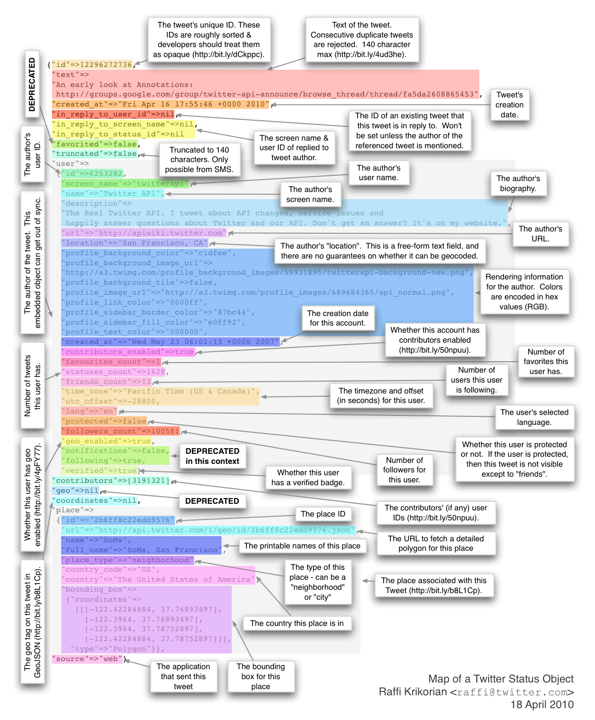

This graphic is from 2010 and is thus outdated. Up-to-date information here:

<https://dev.twitter.com/overview/api/tweets>